**MOTION DETECTION SYSTEM**

**Using ki-cad**

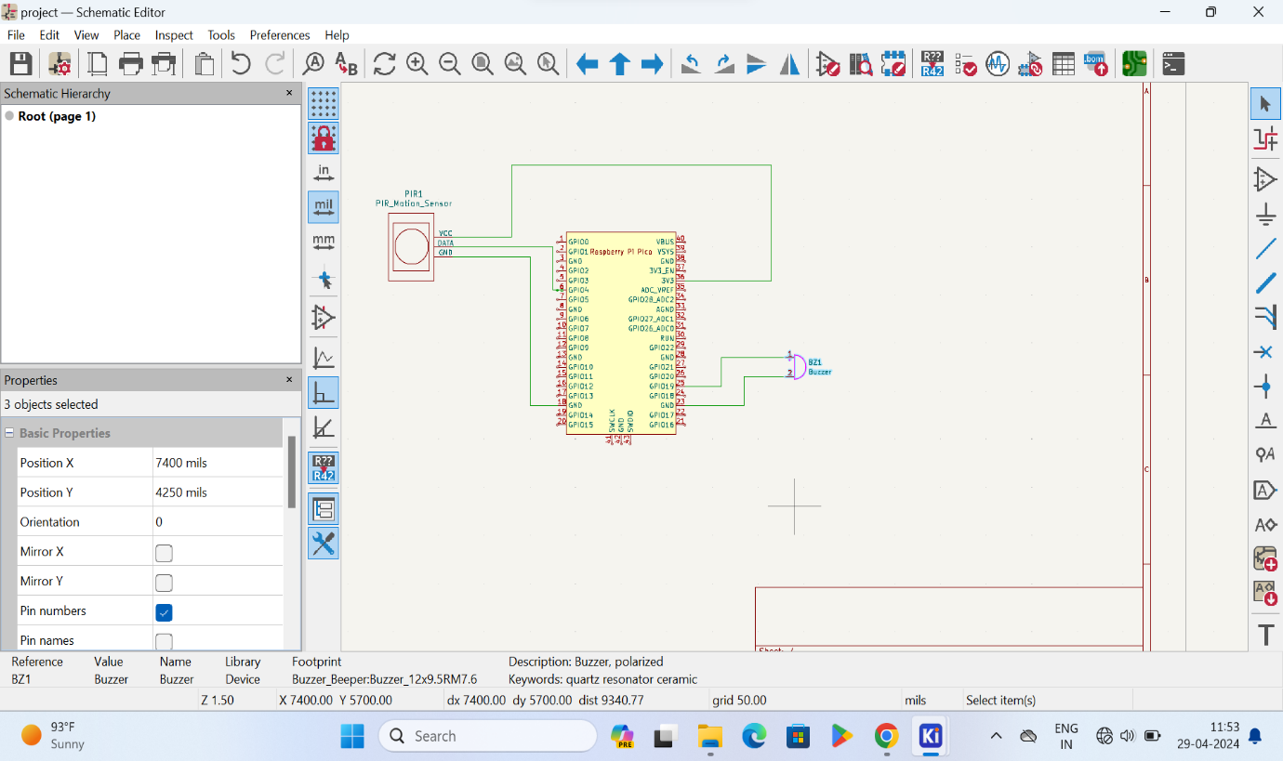

**PCB LAYOUT:**

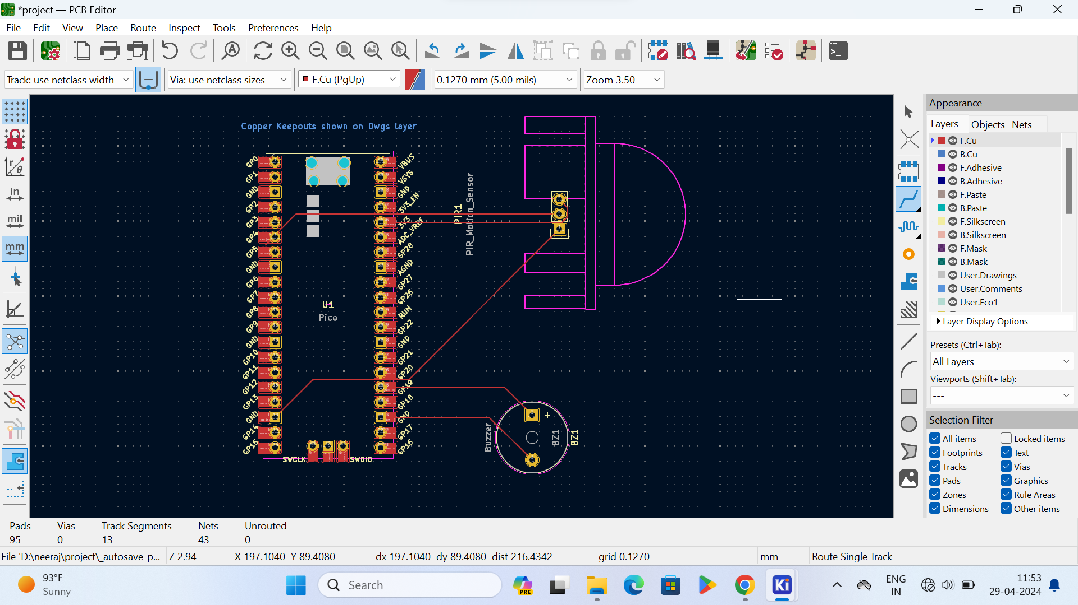

**3D-VIEW OF PCB:**

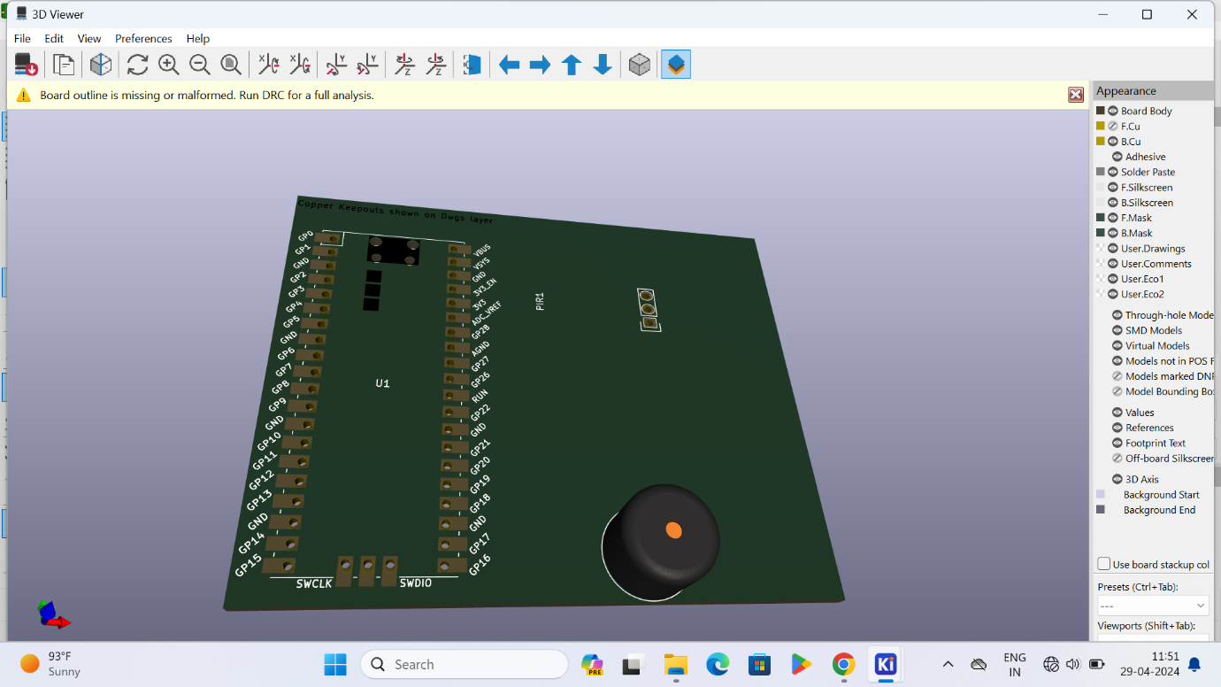

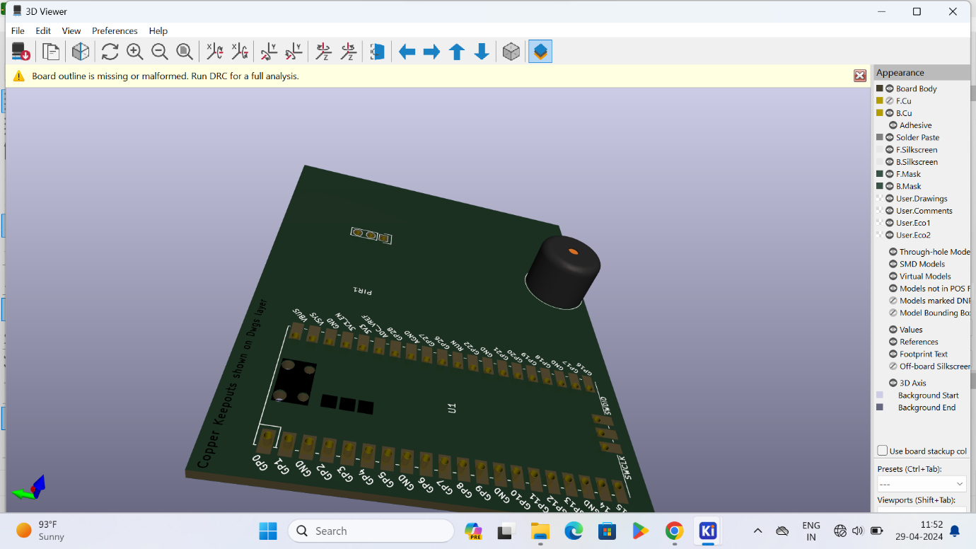

**BACK SIDE OF 3D-VIEW:**

